Electronics Lesson 1 - Student

**Draw a Circuit**

**Arduino Board**

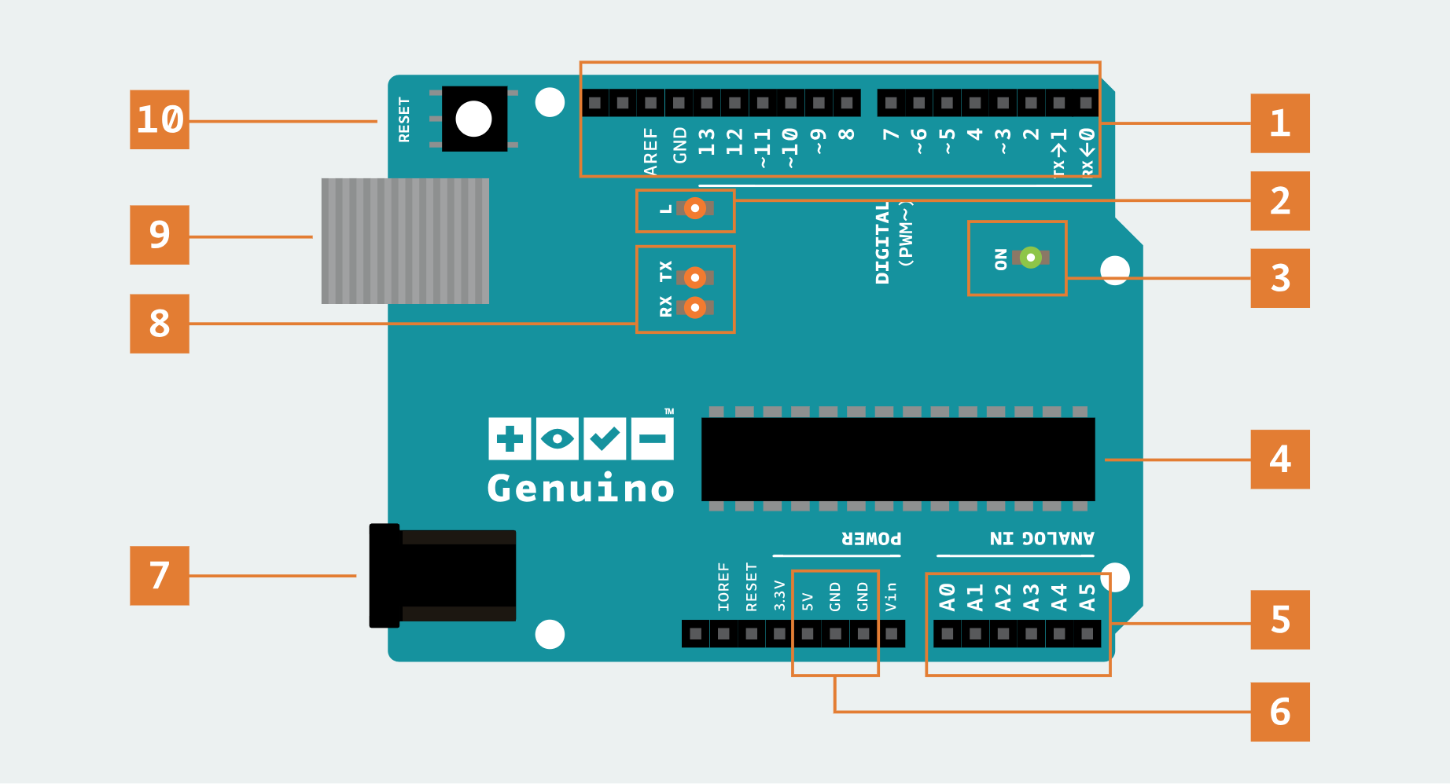

**Bread Board**

